# Full Stack Development with MERN

# 1. Introduction

## Project Title: ShopEZ: E-commerce Application

## Team ID: NM2024TMID11582

## Team Members:

1. **Sabari Sriram V** - *Frontend Developer & Team Lead*: Responsible for leading the team and developing the user interface, focusing on creating reusable UI components and ensuring a smooth user experience.
2. **Mugeshwaran B** - *Backend Developer*: Focuses on setting up server-side functionalities, implementing APIs, and managing data flow between the frontend and backend.
3. **Ruhasan J** - *Database Manager*: Manages database schema design, ensuring efficient data storage and retrieval for users, complaints, and messages.
4. **Ravishankar Kumar** - *Frontend Developer*: Works on styling and layout design using Bootstrap and Material UI to enhance the visual appeal and usability of the application.
5. **Saddam Hussain** - *Quality Assurance & Documentation*: Handles testing to ensure smooth functionality, along with documenting project development processes and user guidelines.

# 2. Project Overview

## Purpose:

The ShopEZ ecommerce website is a full-featured, user-friendly platform built using the MERN stack (MongoDB, Express.js, React.js, Node.js) that enables customers to browse, purchase, and track products online. Designed for efficient shopping and seamless user experience, ShopEZ provides a robust, centralized platform for product management, secure checkout, and real-time order tracking. This website aims to enhance customer convenience by integrating secure payment options, a comprehensive catalog, and a personalized shopping experience.

## Features:

1. **User Registration and Authentication**: Users can create accounts to save their preferences, view past orders, and track current orders.
2. **Product Browsing and Filtering**: Users can browse products by category, use filters for quick searching, and view detailed product descriptions, images, and reviews.
3. **Shopping Cart and Checkout**: Users can add items to their cart, manage quantities, and proceed through a secure checkout process.
4. **Order Tracking and Notifications**: Customers receive updates on their order status and can track delivery in real-time.
5. **Admin Dashboard for Inventory Management**: Admin users can manage product listings, monitor inventory, and oversee order statuses.
6. **Security and Payment Integration**: The platform ensures data security through user authentication, encrypted transactions, and compliance with payment gateway standards.

# 3. Architecture

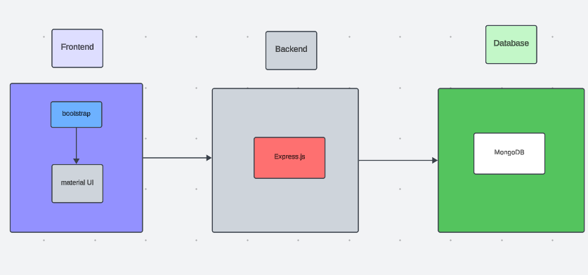

## Frontend:

* The frontend of ShopEZ is built using **React.js**, providing a dynamic and responsive user interface. React enables component-based architecture, allowing for reusable UI elements and efficient DOM updates, which improve the user experience.
* **Axios** is used on the frontend to make RESTful API calls to the backend, allowing seamless data retrieval and updates, such as fetching product listings, submitting orders, and retrieving order statuses.
* **Bootstrap** and **Material UI** are incorporated to create a visually appealing, user-friendly design across all devices. These libraries help ensure that ShopEZ is accessible and offers a consistent experience for all users, including customers and administrators.

## Backend:

* The backend of ShopEZ is powered by **Express.js**, a lightweight and flexible Node.js framework that handles the server-side logic, manages API endpoints, and processes requests from the frontend.
* **RESTful APIs** facilitate the communication between the frontend and backend, enabling features such as user authentication, product management, and order processing.

## Database:

* **MongoDB** is the database used for ShopEZ, chosen for its flexibility and scalability. MongoDB enables efficient storage and retrieval of data, including user information, product details, and order history. With its document-based structure, MongoDB can easily adapt to various data models required for ecommerce, such as user profiles, shopping carts, and order records.
* MongoDB ensures high availability and fast access to critical data, supporting smooth user interactions and efficient order processing.

# 4. Setup Instructions

## Prerequisites:

To develop a full-stack ecommerce website like ShopEZ using Node.js, Express.js, MongoDB, and React.js, the following prerequisites are essential:

#### Node.js and npm

* **Node.js**: A powerful JavaScript runtime environment that allows server-side JavaScript execution. It provides a scalable platform for building network applications.
* **Installation**: [Download Node.js](https://nodejs.org/en/download/) and npm on your development machine for server-side JavaScript execution.

#### Express.js

* **Express.js**: A lightweight web application framework for Node.js. It simplifies the development of robust APIs and server logic with features like routing, middleware, and modular architecture.

## Installation:

Open your command prompt or terminal and run:  
Copy code

npm install express

#### MongoDB

* **MongoDB**: A flexible and scalable NoSQL database that stores data in a JSON-like format, making it suitable for large data volumes in an ecommerce setting.
* **Setup**: [Download MongoDB](https://www.mongodb.com/try/download/community) and configure it to store and retrieve application data such as user accounts, product listings, and order records.
* **Database Connectivity**: Use Mongoose, an ODM (Object-Document Mapping) library, to simplify interactions with MongoDB and perform CRUD operations. Guide for connecting Node.js and MongoDB with Mongoose.

#### React.js

* **React.js**: A JavaScript library for building user interfaces, enabling the creation of interactive and reusable UI components, ideal for dynamic ecommerce applications.
* **Installation**: [React installation guide](https://reactjs.org/docs/create-a-new-react-app.html) to set up the user-facing part of ShopEZ, including product browsing, shopping cart management, and the checkout experience.

#### HTML, CSS, and JavaScript

* Basic knowledge of HTML (structure), CSS (styling), and JavaScript (interactivity) is essential for frontend development.

#### Front-end Libraries

* **Material UI and Bootstrap**: These libraries provide pre-designed components and responsive styling options, enhancing the user experience across different devices.

#### Version Control

* **Git**: Use Git for version control to facilitate collaboration and track changes. Platforms like GitHub or Bitbucket can host your repository.
* **Download Git**: [Installation instructions](https://git-scm.com/downloads) for setting up Git on your system.

#### Development Environment

* Choose a code editor or IDE that best suits your workflow, such as Visual Studio Code, Sublime Text, or WebStorm.
* **Visual Studio Code**: [Download here](https://code.visualstudio.com/download).

### Setting Up the Project

1. **Clone the Repository**:

Open your terminal or command prompt and navigate to the directory where you want to store the ShopEZ app.

Clone the repository with:  
bash  
Copy code

git clone https://github.com/your-username/shop-ez.git

1. **Install Dependencies**:

Navigate into the cloned repository directory:  
bash  
Copy code

cd shop-ez

Install frontend dependencies:  
bash  
Copy code

cd client

npm install

Install backend dependencies:  
bash  
Copy code

cd ../server

npm install

1. **Start the Development Server**:

To start the development server, execute the following command:  
sql  
Copy code

npm start

The ShopEZ ecommerce website will be accessible at<http://localhost:3000>.

With this setup, you’re ready to further develop, customize, and test the ShopEZ ecommerce application in your local environment.

# 5. Folder Structure

## Client:

The 'client' directory contains all frontend files, organized into components, pages, services, and assets. Reusable UI components are stored in a way that ensures modular and scalable code.

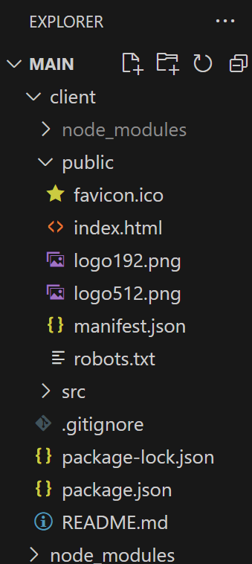

## Server:

The 'server' directory contains backend logic, API routes, and database configurations. Modular routes handle functionalities like user authentication, product management, and transaction processing.

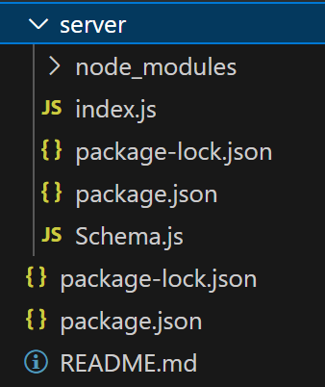

# 6. Running the Application

To successfully launch and run the *ShopEZ* eCommerce application, the frontend and backend need to be started separately, as they are developed independently. This guide outlines the steps to set up and run both the frontend and backend components, ensuring that they connect seamlessly for full functionality.

#### 1. Running the Frontend

The frontend of *ShopEZ* is a React-based application that handles the user interface and all client-side operations. This includes displaying product listings, managing user interactions, and handling API requests to the backend for data retrieval and updates. To run the frontend, follow these steps:

1. **Navigate to the Client Directory**:
   * Open your terminal or command prompt.
   * Navigate to the directory where the frontend code is located. This should be the directory where you initialized the React app, often named client.

Example command:  
bash  
Copy code

cd client

1. **Install Dependencies**:

Before starting the application, ensure that all dependencies are installed. Run the following command to install any missing packages specified in package.json:  
bash  
Copy code

npm install

1. **Start the Frontend Server**:

After installing dependencies, start the React development server with the following command:  
bash  
Copy code

npm start

* + This command will launch the application on http://localhost:3000 by default. You should see the home page of *ShopEZ* in your browser if everything is set up correctly.
  + The frontend server supports live reloading, so any changes made to the code will automatically update in the browser.

1. **Check Frontend Components**:
   * Ensure that key components, like the home page, product pages, and user profile page, are rendering correctly. Verify that the navigation system allows smooth access to different sections of the app.

#### 2. Running the Backend

The backend of *ShopEZ* is powered by Express.js, handling server-side logic, data processing, and interactions with the MongoDB database. The backend provides APIs that the frontend can call to perform operations like product retrieval, user authentication, and complaint management. To run the backend, proceed as follows:

1. **Navigate to the Server Directory**:
   * Open a new terminal window or tab.
   * Move to the directory where the backend code is located, typically named server.

Example command:  
bash  
Copy code

cd server

1. **Install Backend Dependencies**:

Similar to the frontend, the backend requires certain packages to function correctly. Use the following command to install all required dependencies as listed in package.json:  
bash  
Copy code

npm install

1. **Configure Environment Variables**:
   * Ensure that environment variables, such as database URI and authentication keys, are correctly configured in a .env file within the backend directory. This file should define:
     + DB_URI: Connection string for MongoDB.
     + JWT_SECRET: Secret key for JSON Web Token (JWT) authentication.
     + PORT: Port on which the backend server will run (if different from the default).
2. **Start the Backend Server**:

After all configurations are in place, start the backend server by running:  
bash  
Copy code

npm start

* + This command will initiate the server on http://localhost:5000 (or the specified port).
  + The backend server will listen for API requests from the frontend and respond with data or process updates, depending on the request type.

1. **Verify API Endpoints**:
   * Once the backend server is running, verify key API endpoints like /api/products, /api/users, and /api/complaints to ensure they are accessible and working correctly. These endpoints are essential for functionalities like product listing, user registration, and complaint submission.

#### 3. Testing the Full Application

With both the frontend and backend running, open the browser and navigate to http://localhost:3000 to access *ShopEZ*. Test the following core functionalities:

* **User Authentication**: Confirm that user registration, login, and profile management work as expected.
* **Product Interaction**: Ensure that product listings load from the backend, and features like adding items to the cart function correctly.
* **Complaint Management**: Check that users can register complaints, and the status updates as it moves through different stages (pending, assigned, resolved).

# 7. API Documentation

The *ShopEZ* backend API provides endpoints to manage user actions, product handling, order processing, and complaint registration. Each endpoint is designed to handle specific requests and streamline interactions between the frontend and backend.

#### 1. User Authentication Endpoints

These endpoints manage user registration, login, and profile access for secure user interactions.

* **Register a New User**
  + **Endpoint**: /api/users/register
  + **Method**: POST
  + **Description**: Registers a new user with their name, email, password, and phone number.
  + **Parameters**: name, email, password, phone
* **Login User**
  + **Endpoint**: /api/users/login
  + **Method**: POST
  + **Description**: Authenticates the user and provides a session token if credentials are valid.
  + **Parameters**: email, password
* **User Profile**
  + **Endpoint**: /api/users/profile
  + **Method**: GET
  + **Description**: Retrieves the profile information of the authenticated user.
  + **Parameters**: Requires authentication token.

#### 2. Product Management Endpoints

These endpoints allow users to view and interact with product listings.

* **Get All Products**
  + **Endpoint**: /api/products
  + **Method**: GET
  + **Description**: Fetches a list of all available products.
  + **Parameters**: None.
* **Get Product Details**
  + **Endpoint**: /api/products/:id
  + **Method**: GET
  + **Description**: Retrieves detailed information about a specific product.
  + **Parameters**: id (Product ID)

#### 3. Order Processing Endpoints

These endpoints handle order placement and tracking for users.

* **Place an Order**
  + **Endpoint**: /api/orders
  + **Method**: POST
  + **Description**: Places a new order with a list of items.
  + **Parameters**: userId, items (array with product ID and quantity)
* **Get Order Status**
  + **Endpoint**: /api/orders/:orderId
  + **Method**: GET
  + **Description**: Retrieves the current status of a specific order.
  + **Parameters**: orderId (Order ID)

#### 4. Complaint and Support Endpoints

These endpoints enable users to register complaints and communicate with support agents.

* **Submit a Complaint**
  + **Endpoint**: /api/complaints
  + **Method**: POST
  + **Description**: Registers a new complaint related to an order or product.
  + **Parameters**: userId, productId, description
* **Get Complaint Status**
  + **Endpoint**: /api/complaints/:complaintId
  + **Method**: GET
  + **Description**: Retrieves the current status of a specific complaint.
  + **Parameters**: complaintId (Complaint ID)
* **Message Support Agent**
  + **Endpoint**: /api/chat
  + **Method**: POST
  + **Description**: Allows users and agents to send messages about a complaint.
  + **Parameters**: complaintId, userId, message

# 8. Authentication

In *ShopEZ*, secure user authentication is managed through **JSON Web Tokens (JWT)**, ensuring that only authorized users can access protected resources and functionalities. This setup is crucial for maintaining data security and controlling access based on user roles.

#### JWT-Based Authentication Process

1. **User Login and Token Generation**:
   * Upon successful login, *ShopEZ* generates a JWT for the user. This token contains encoded information such as the user's ID and role (e.g., customer, vendor, or admin).
   * The JWT is then sent to the user’s client-side application, where it is stored (usually in local storage or cookies) for subsequent requests.
2. **Token Validation for Protected Routes**:
   * For each protected route, *ShopEZ* requires a valid JWT in the request headers.
   * The backend validates the JWT before granting access to ensure that the request is made by an authenticated user.

#### Role-Based Access Control (RBAC)

*ShopEZ* uses role-based access control to restrict certain routes and functionalities based on the user’s role. Key aspects of this include:

* **User Roles**:
  + *Customer*: Can view products, place orders, and submit complaints.
  + *Vendor (Admin)*: Has access to manage products, orders, complaints, and user profiles.
* **Protected Routes**:
  + Only users with a valid JWT can access routes such as profile management, order placement, complaint registration, and customer support messaging.
  + Administrative functionalities, like product management and order review, are restricted to users with a vendor/admin role, ensuring that only authorized personnel can modify critical resources.

#### Session Management and Expiration

* *ShopEZ* implements session expiration to enhance security. JWTs are designed to expire after a set period, requiring users to log in again to obtain a fresh token.
* When a token expires, users must re-authenticate to maintain access, reducing the risk of unauthorized access due to prolonged sessions.

#### Middleware for Authorization Control

The *ShopEZ* backend employs custom middleware to handle authentication and authorization:

* **Authentication Middleware**: Validates the JWT in incoming requests. If the token is invalid or absent, the request is denied.
* **Authorization Middleware**: Checks the user role associated with the JWT, permitting or restricting access to specific routes based on role requirements.

# 9. User Interface

The *ShopEZ* platform is designed with an intuitive and user-friendly interface to enhance the shopping experience for users. Below is an overview of the key UI features, including screenshots or visual descriptions of primary sections such as the Home Page, Product Page, and Cart Page.

#### Home Page

* **Overview**:
  + The *ShopEZ* Home Page welcomes users with a visually engaging layout showcasing featured products, trending items, and promotional banners.
  + The page includes a search bar and category navigation, allowing users to easily browse or search for products.
* **Key Features**:
  + **Product Categories**: Displayed prominently for easy access to various categories (e.g., Electronics, Fashion, Home Essentials).
  + **Promotions & Banners**: Highlight current offers, new arrivals, or seasonal promotions, drawing users to the latest deals.
  + **Responsive Design**: Adapted for desktop and mobile devices to ensure a seamless experience across platforms.

#### Product Page

* **Overview**:
  + The Product Page provides detailed information about each item, including images, description, price, availability, and customer reviews.
  + Users can view multiple images, read specifications, and check ratings before making a purchase.
* **Key Features**:
  + **Detailed Product Information**: Each product displays detailed descriptions, including specifications, price, availability, and seller information.
  + **Product Reviews**: Users can view ratings and customer reviews to make informed purchasing decisions.
  + **Add to Cart and Wishlist Options**: Convenient buttons to add items to the cart or wishlist for later purchases.
  + **Quantity Selection**: Allows users to choose the desired quantity before adding to the cart, ensuring a smooth shopping experience.

#### Cart Page

* **Overview**:
  + The Cart Page gives users an overview of items they plan to purchase, along with options to modify quantities or remove products.
  + It includes a subtotal summary and checkout button for easy access to the next steps.
* **Key Features**:
  + **Product Summary**: Lists each product added to the cart with quantity, price, and total for easy review.
  + **Editable Quantity and Removal**: Users can adjust quantities or remove items directly within the cart.
  + **Order Summary and Checkout**: Provides a subtotal, tax, and total cost breakdown, along with a prominent checkout button for quick access to the payment process.

# 10. Testing

A comprehensive testing strategy is implemented for *ShopEZ* to ensure functionality, reliability, and an optimal user experience. This strategy involves various testing methodologies, targeting both backend and frontend components of the application.

#### Unit Testing for Backend Logic

* **Objective**:
  + Unit tests focus on individual functions and methods within the backend, verifying that each one works as expected in isolation. This includes business logic for handling users, products, orders, and transactions.
* **Implementation**:
  + Using **Jest** and **Mocha**, tests are created for core backend functions, such as data validation, authentication, order calculations, and CRUD operations for products and users.
  + Mocking libraries, like **Sinon**, simulate database calls and dependencies to ensure accurate testing of functions without requiring a database connection.
* **Examples**:
  + **User Authentication**: Tests validate user login, JWT generation, and role-based access control to secure routes.
  + **Order Processing**: Verifies calculations for order totals, discounts, and inventory adjustments.

#### Integration Testing for API Routes

* **Objective**:
  + Integration tests assess the interaction between different components by testing API endpoints from end to end. These tests ensure that the backend services work cohesively and respond correctly to various requests.
* **Implementation**:
  + Routes for user registration, login, product listing, cart management, and order placement are tested using Jest and Mocha to verify correct responses, status codes, and data retrieval.
  + Mock databases with tools like **MongoDB in-memory server** are used to simulate database interactions and test data consistency.
* **Examples**:
  + **User Registration and Login**: Tests validate input validation, error handling, and successful JWT issuance for registered users.
  + **Product API Endpoints**: Checks product retrieval, filtering, and pagination to ensure a smooth product browsing experience for users.

#### UI Testing for React Components

* **Objective**:
  + UI testing verifies that React components render correctly and interact as expected. This includes visual layout, user interactions, and component behaviors within the *ShopEZ* frontend.
* **Implementation**:
  + **Jest** and **React Testing Library** are used to test individual UI components, ensuring they render accurately and respond to user actions.
  + Tests are created for primary user flows, such as adding products to the cart, navigating product pages, and completing the checkout process.
  + **End-to-end testing** with **Cypress** validates the complete user journey from landing on the homepage to placing an order, simulating real user behavior.
* **Examples**:
  + **Cart Component**: Ensures items added to the cart are displayed correctly, with the correct quantities and pricing.
  + **Checkout Flow**: Tests the entire checkout process to confirm users can finalize their orders seamlessly without errors.

# 11. Screenshots or Demo

#### Login Page

* **Description**: The login page is the gateway to the *ShopEZ* platform. Users can log in with their registered credentials (email and password) to access their accounts.
* **Features**:
  + Fields for email and password entry.
  + "Forgot Password" option for users to recover their credentials.
  + Error messages for incorrect login attempts.

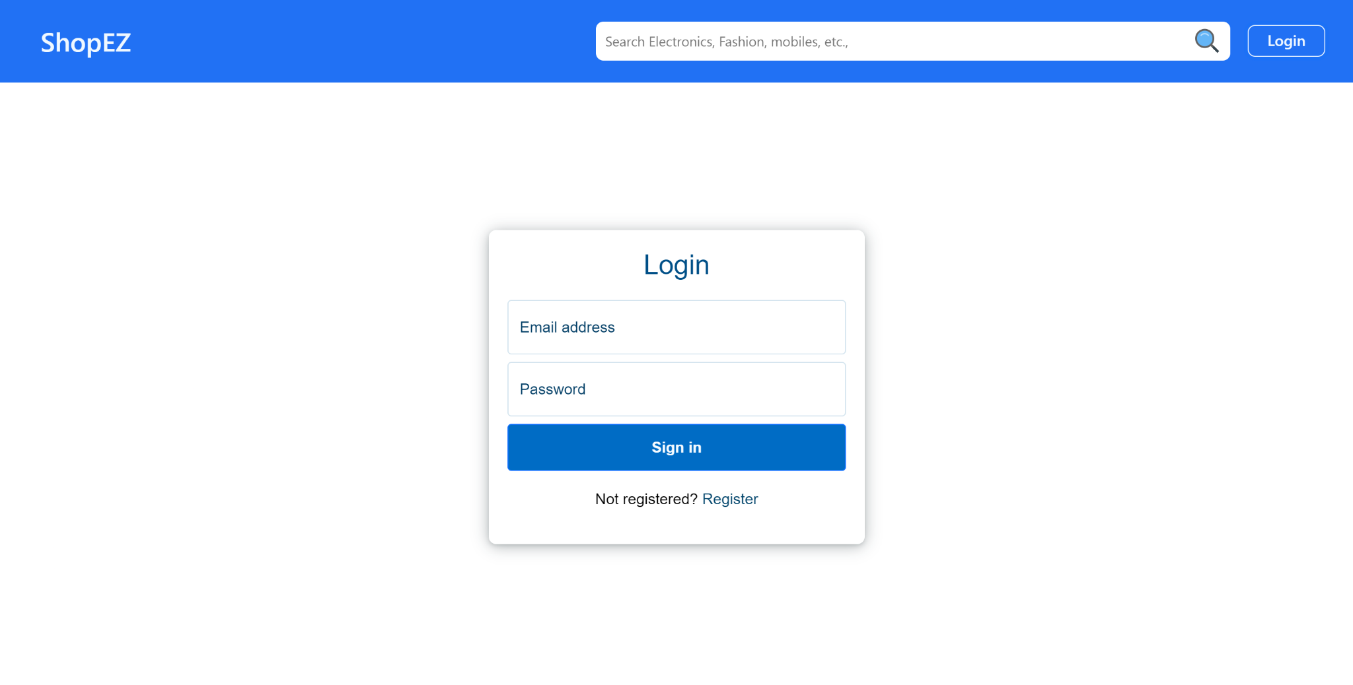

#### 2. Landing Page (Home Page)

* **Description**: The landing page welcomes users with a clean interface, showcasing featured products, product categories, and promotional banners.
* **Features**:
  + Product listings with easy navigation to product details.
  + Search bar for quick product search.
  + Access to categories and special offers.

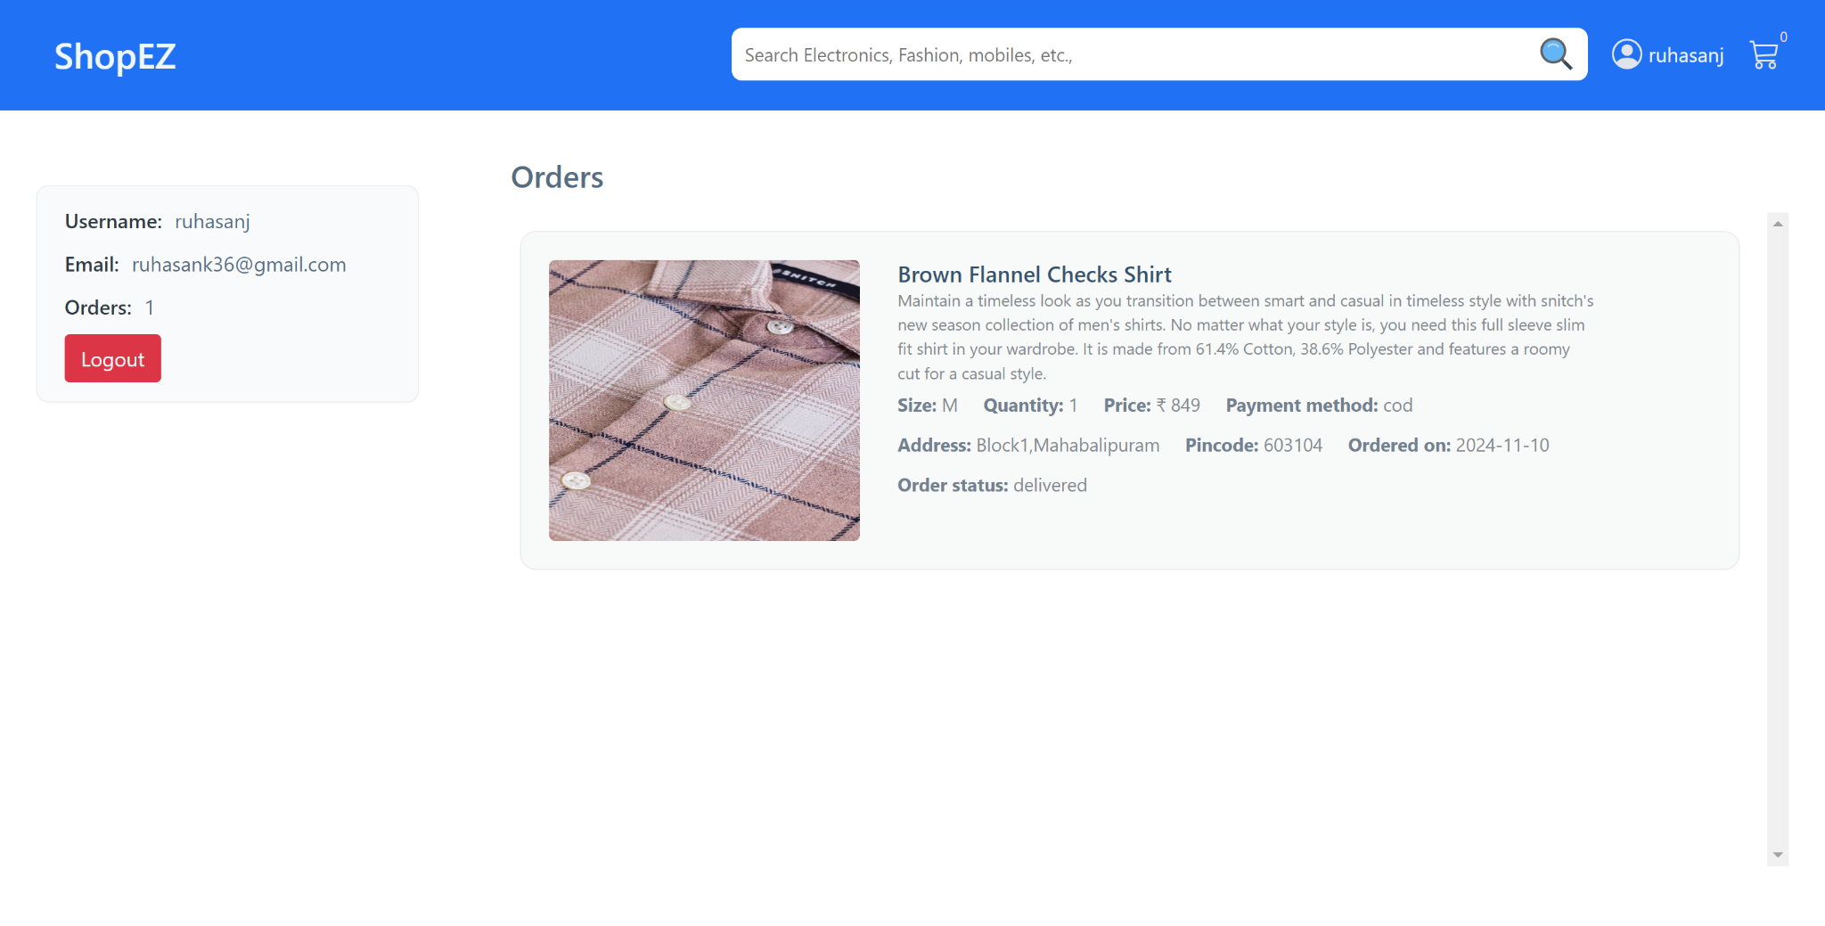

#### 3. Cart Page

* **Description**: The cart page displays items added by the user, along with the ability to modify quantities or remove products.
* **Features**:
  + Displays product name, price, quantity, and total cost.
  + Option to update product quantities or remove items.
  + A button to proceed to checkout.



#### 4. Admin Dashboard

* **Description**: The admin dashboard allows the platform administrators to manage users, orders, and products. It provides a comprehensive overview of the system’s operations.
* **Features**:
  + Overview of active users, products, and orders.
  + Options for adding, updating, or deleting products.
  + Access to order management, including processing and tracking.

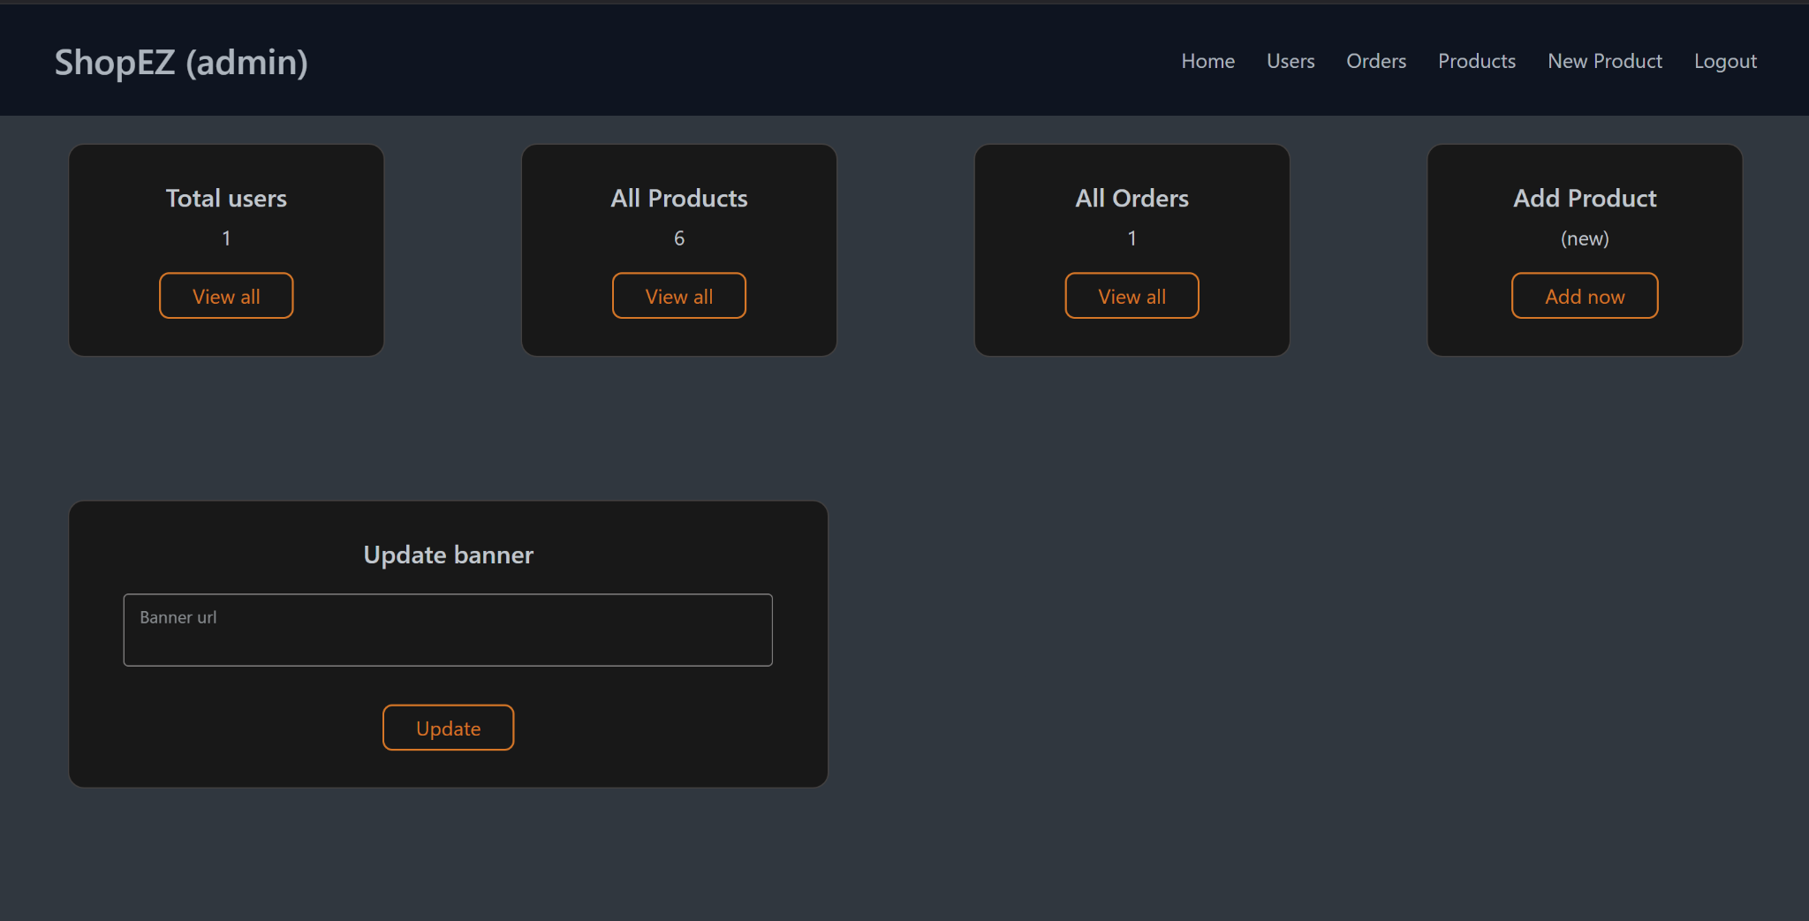

Before starting to work on this project, let’s see the demo.

**Project demo:** [**https://drive.google.com/file/d/12vqr61jkfXumCnomRuEHV5ukAwEPIIlv/view?usp=sharing**](https://drive.google.com/file/d/12vqr61jkfXumCnomRuEHV5ukAwEPIIlv/view?usp=sharing)

**Use the code** in: <https://github.com/tedLcode/shopEZ>

or follow the videos below for better understanding.

# 12. Known Issues

Below are some known issues and limitations in the *ShopEZ* Ecommerce platform, along with potential improvements that could enhance the user experience and system performance:

#### 1. Loading Speed with Large Product Data Sets

* **Issue**: The application experiences slower load times when displaying large numbers of products on the product listing page, especially when there are hundreds or thousands of items in the catalog.
* **Potential Improvements**:
  + **Pagination**: Implement pagination or infinite scrolling to limit the number of products loaded at once, improving load time.
  + **Lazy Loading**: Use lazy loading techniques for images and product details to load only visible content initially.
  + **Database Indexing**: Optimize MongoDB queries and indexes to speed up data retrieval for large datasets.

#### 2. Slow Checkout Process on High Traffic

* **Issue**: The checkout process can be slow when many users are accessing the platform simultaneously. This occurs due to simultaneous database operations related to order placement, inventory updates, and user authentication.
* **Potential Improvements**:
  + **Caching**: Implement caching mechanisms for frequently accessed data, such as product details, to reduce database load during checkout.
  + **Asynchronous Processing**: Move certain backend tasks, such as payment processing and inventory checks, to background jobs to avoid blocking the user experience.

#### 3. Incomplete Error Handling for Failed Payments

* **Issue**: In cases where the payment gateway fails or is interrupted, the system may not always display clear error messages, which may confuse users.
* **Potential Improvements**:
  + **Improved Error Messages**: Enhance error handling for payment failures by providing more specific error messages to users, guiding them to retry or check their payment details.
  + **Transaction Logs**: Implement better logging for failed transactions to allow for easier troubleshooting and support resolution

#### 4. Admin Dashboard Performance

* **Issue**: The admin dashboard may lag or be less responsive when trying to display large sets of user data, orders, or products. This affects the ability to quickly manage or track orders.
* **Potential Improvements**:
  + **Data Filtering**: Integrate filters and search options in the admin dashboard to narrow down data queries, improving page load time.
  + **Background Data Processing**: Move data-heavy operations to background tasks or asynchronous processes to improve the user interface’s responsiveness.

#### 5. Inconsistent Mobile Layouts

* **Issue**: While the application is responsive, some UI components may not display optimally on smaller mobile screens, leading to poor user experience on certain devices.
* **Potential Improvements**:
  + **Mobile Optimization**: Further optimize CSS media queries to ensure that all components adapt perfectly to various screen sizes, especially on smaller mobile devices.
  + **Responsive Testing**: Perform extensive testing across various mobile devices to identify and fix any layout inconsistencies.

#### 6. Limited Payment Gateway Options

* **Issue**: Currently, the application supports a limited number of payment gateways. Users may encounter issues if their preferred payment method is unavailable.
* **Potential Improvements**:
  + **Add More Payment Options**: Integrate additional payment gateways like PayPal, Stripe, or local payment systems to cater to a wider audience and ensure smooth transactions.

#### 7. Incomplete User Authentication Flow

* **Issue**: The user authentication flow could be improved with additional security features, such as multi-factor authentication (MFA) and password strength checks.
* **Potential Improvements**:
  + **Multi-Factor Authentication (MFA)**: Implement MFA for user accounts to increase security.
  + **Password Strength Indicators**: Add password strength indicators during the registration and password change processes to ensure stronger passwords are used.

#### 8. Lack of Advanced Search Features

* **Issue**: The search functionality is basic and may not provide adequate filtering for users who want to narrow down results based on specific product attributes such as size, color, price range, etc.
* **Potential Improvements**:
  + **Advanced Filters**: Add more advanced search filters and sorting options to allow users to easily find products that match their preferences.
  + **Search Suggestions**: Integrate search suggestions or autocomplete features to improve the search experience.

# 13. Future Enhancements

As *ShopEZ* continues to evolve, there are several exciting features and improvements that can be added to further enhance the user experience, improve operational efficiency, and stay competitive in the rapidly growing e-commerce industry. Below are some potential future enhancements for the *ShopEZ* Ecommerce platform:

#### 1. AI-Powered Product Recommendations

* **Feature**: Integrating Artificial Intelligence (AI) algorithms to provide personalized product recommendations based on a user's browsing history, purchase behavior, and preferences.
* **Benefits**:
  + **Improved User Experience**: Customers will receive personalized product suggestions, making it easier to discover items that match their tastes and needs.
  + **Increased Sales**: By suggesting relevant products, the platform can boost cross-selling and upselling, leading to higher average order values.
* **Implementation**:
  + Leverage machine learning models to analyze user data and predict products that a customer is likely to purchase.
  + Display these recommendations on the homepage, product pages, and cart page to maximize visibility.

#### 2. Enhanced Order Tracking

* **Feature**: Offering real-time, detailed order tracking that allows users to see the status of their orders from dispatch to delivery, along with the ability to receive notifications at key stages.
* **Benefits**:
  + **Transparency**: Customers will have greater visibility into their order status, reducing anxiety and increasing satisfaction.
  + **Customer Engagement**: Automated notifications via email or SMS will keep users informed about the progress of their orders.
* **Implementation**:
  + Integrate with shipping carriers’ APIs to fetch live tracking data and display it in a user-friendly interface.
  + Allow users to track multiple orders simultaneously and provide estimated delivery times.

#### 3. Chatbots for Customer Support

* **Feature**: Introducing AI-driven chatbots that assist customers in real-time, answering queries about products, orders, and general support.
* **Benefits**:
  + **24/7 Support**: Chatbots will provide around-the-clock assistance, allowing customers to get immediate answers to their questions, even outside of business hours.
  + **Efficiency**: Automation will reduce the load on human customer support agents, allowing them to focus on more complex inquiries while the chatbot handles basic questions.
  + **Cost Reduction**: Reduces operational costs by automating repetitive tasks and improving customer satisfaction through instant responses.
* **Implementation**:
  + Integrate AI-based chatbot platforms like Dialogflow or Microsoft Bot Framework for real-time interaction.
  + Train the chatbot to handle common inquiries like order status, product availability, return/exchange policies, and troubleshooting issues.

#### 4. Multi-Language and Multi-Currency Support

* **Feature**: Implementing multi-language and multi-currency support to make *ShopEZ* more accessible to a global audience.
* **Benefits**:
  + **Global Reach**: Expands the platform’s reach to non-English speaking customers and facilitates international sales.
  + **Localized Experience**: Customers can shop in their native language and currency, providing a more personalized experience.
* **Implementation**:
  + Use localization frameworks to support multiple languages, adjusting text, dates, and currency formatting based on the user’s region.
  + Integrate payment gateways that support multi-currency transactions.

#### 5. Enhanced Admin Dashboard

* **Feature**: Upgrading the admin dashboard to include more advanced data analytics and reporting features, helping admins make data-driven decisions.
* **Benefits**:
  + **Business Insights**: Admins will have access to detailed reports on sales trends, customer behavior, inventory status, and more.
  + **Efficiency**: Streamlined access to real-time data can help admins make quicker and more informed decisions regarding stock, promotions, and customer service.
* **Implementation**:
  + Integrate tools like Google Analytics, or custom analytics systems to provide insights into user engagement, sales performance, and marketing campaign success.
  + Implement features like product performance tracking, customer lifetime value analysis, and real-time sales data visualization.

#### 6. Voice Search Integration

* **Feature**: Allowing customers to search for products using voice commands, making the shopping experience more intuitive and hands-free.
* **Benefits**:
  + **Convenience**: Voice search allows customers to quickly find products without typing, making it especially useful for mobile and smart device users.
  + **Innovation**: Voice search can improve the accessibility of the platform and enhance the user experience by adding a modern, futuristic feature.
* **Implementation**:
  + Integrate speech recognition APIs like Google Speech API or Amazon Lex to allow users to search products using voice commands.
  + Provide a voice-enabled search bar or button on key pages like the homepage, product listing, and search results.

#### 7. Subscription Model for Products

* **Feature**: Implementing a subscription-based model for certain products, allowing users to subscribe and receive regular deliveries at discounted rates.
* **Benefits**:
  + **Customer Retention**: Subscribers are more likely to make repeat purchases and stick with the platform for long-term needs.
  + **Stable Revenue Stream**: Recurring subscriptions can provide a steady flow of revenue, reducing dependency on one-time purchases.
* **Implementation**:
  + Enable customers to subscribe to regular deliveries for consumable products such as groceries, beauty products, or personal care items.
  + Offer incentives like discounts or free shipping for users who opt for a subscription plan.

For any further doubts or help, please consider the code from the google drive,

<https://drive.google.com/drive/folders/15ifq-3JJoXotnDgvTA8YXutIErJocVFc?usp=sharing>

The demo of the app is available at:

<https://drive.google.com/drive/folders/15ifq-3JJoXotnDgvTA8YXutIErJocVFc?usp=sharing>